

BLOOD DONATION WEBSITE

INTERNSHIP PROJECT REPORT

by

**NAME:**

Harshavardhan Thatikonda- 2203A52180

Sai Sanjana Jadhav- 2203A52190

Prathibha Samudrala- 2203A51060

**Under the guidance of PROFESSOR:**

Prof. L. Anjaneyulu

**DATE: 8**th JULY, 2024

**DEPARTMENT OF ELECTRONICS AND COMMUNICATION ENGINEERING NATIONAL INSTITUTE OF TECHNOLOGY, WARANGAL**

**June 2023**

NATIONAL INSTITUTE OF TECHNOLOGY

**WARANGAL - 506 004**

**CERTIFICATE**

**This is to certify that _Harshavardhan Thatikonda of SR UNIVERSITY have successfully completed a Project titled “BLOOD DONATION WEBSITE”, as part of Summer Internship Programme under my guidance at National Institute of Technology, Warangal, Telangana, during 6-06-2024 to 8-07-2024.**

**Prof L.Anjaneyulu, ECE Visvesvaraya Centre for Skill Development**

**NIT, Warangal**

NATIONAL INSTITUTE OF TECHNOLOGY

**WARANGAL - 506 004**

**CERTIFICATE**

**This is to certify that _Sai Sanjana Jadhav of SR UNIVERSITY have successfully completed a Project titled “BLOOD DONATION WEBSITE”, as part of Summer Internship Programme under my guidance at National Institute of Technology, Warangal, Telangana, during 6-06-2024 to 8-07-2024.**

**Prof L.Anjaneyulu, ECE Visvesvaraya Centre for Skill Development**

**NIT, Warangal**

NATIONAL INSTITUTE OF TECHNOLOGY

**WARANGAL - 506 004**

**CERTIFICATE**

**This is to certify that _Prathibha Samudrala of SR UNIVERSITY have successfully completed a Project titled “BLOOD DONATION WEBSITE”, as part of Summer Internship Programme under my guidance at National Institute of Technology, Warangal, Telangana, during 6-06-2024 to 8-07-2024.**

**Prof L.Anjaneyulu, ECE Visvesvaraya Centre for Skill Development**

**NIT, Warangal**

TABLE OF CONTENTS

1. Introduction………………………………………………………………………………………………………..
2. Problem Statement………………………………………………………………………………………………
3. Software Code…………………………………………………………………………………………………….
4. Results……………………………………………………………………………………………………………….
5. Conclusion ………………………………………………………………………………………………………..

# INTRODUCTION

Welcome to our Blood Bank Website, a dedicated platform designed to connect blood donors with recipients in need, ensuring that life-saving blood is available whenever required. Our mission is to bridge the gap between donors and recipients by providing an efficient and secure system that encourages and supports blood donation. Users can easily register as donors, helping to save lives by providing much-needed blood, or request blood for themselves or others in need. Our platform, powered by robust backend technology and secure database management with phpMyAdmin, ensures that all information is handled with the utmost privacy and efficiency. Join us in making a difference and supporting public health through the simple yet profound act of blood donation.

# PROBLEM STATEMENT

Blood banks often face challenges in efficiently managing and matching blood donations with patient needs due to the lack of an integrated, user-friendly platform. This results in delayed response times and potential shortages of critical blood types. Our objective is to develop a comprehensive blood bank website that streamlines the process of blood donation and requests, ensuring timely and effective communication between donors, recipients, and blood bank administrators.

# SOFTWARE CODE:

Index.html

<!DOCTYPE html>

<html lang="en">

<head>

<meta charset="UTF-8">

<meta name="viewport" content="width=device-width, initial-scale=1.0">

<!---------------------------------------------Linking In My Project-------------------------------------------->

<link rel="stylesheet" href="{{ url_for('static', filename='style.css') }}">

<link rel="stylesheet" href="https://cdnjs.cloudflare.com/ajax/libs/font-awesome/6.5.1/css/all.min.css" integrity="sha512-DTOQO9RWCH3ppGqcWaEA1BIZOC6xxalwEsw9c2QQeAIftl+Vegovlnee1c9QX4TctnWMn13TZye+giMm8e2LwA==" crossorigin="anonymous" referrerpolicy="no-referrer" />

<link rel="preconnect" href="https://fonts.googleapis.com">

<link rel="preconnect" href="https://fonts.gstatic.com" crossorigin>

<link href="https://fonts.googleapis.com/css2?family=Courgette&family=Kaushan+Script&family=Nova+Square&display=swap" rel="stylesheet">

<link href="https://fonts.googleapis.com/css2?family=Courgette&family=Kaushan+Script&family=Nova+Square&family=Poppins:wght@600&display=swap" rel="stylesheet">

<link href="https://fonts.googleapis.com/css2?family=Roboto:ital,wght@0,100;0,300;0,400;0,500;0,700;0,900;1,100;1,300;1,400;1,500;1,700;1,900&display=swap" rel="stylesheet">

<link href="https://fonts.googleapis.com/css2?family=Pacifico&family=Poppins:ital,wght@0,100;0,200;0,300;0,400;0,500;0,600;0,700;0,800;0,900;1,100;1,200;1,300;1,400;1,500;1,600;1,700;1,800;1,900&display=swap" rel="stylesheet">

<title>Blood Donation</title>

<link rel="icon" type="image/png" href="{{ url_for('static', filename='drop2.png') }}">

</head>

<body>

<div class="main_box">

<!-------------------------------------------Creating Hamburger Button------------------------------------------------>

<input type="checkbox" id="check">

<div class="first_button">

<label for="check">

<i class="fa-solid fa-bars"></i>

</label>

</div>

<div class="title">

<h1>BLOOD DONATION</h1>

<h6 style="margin-left: 22.5em; color: rgb(255, 233, 233); -webkit-text-stroke: 0.25px black; font-size: 1.5rem;">a small seed for a life</h6>

</div>

<!--------------------------------------------Content of webpage-------------------------------------------------->

<div class="content2">

<img src="https://www.eraktkosh.in/BLDAHIMS/bloodbank/transactions/assets/webp/withoutytp_New2022-Photoroom.png" alt="blood donation day">

<img src="https://t3.ftcdn.net/jpg/04/87/55/66/360_F_487556637_8m5i9zo19NUK06hR82MoIKavJfHLRgi0.jpg" alt="">

<img src="https://c8.alamy.com/comp/2RHDDFH/blood-donation-background-hand-give-tear-of-blood-2RHDDFH.jpg" alt="">

</div>

<div class="content">

<div class="box box1">

<h1 style="color: rgb(169, 0, 0);">Aim and Objective</h1>

<hr> <br>

<img src="{{ url_for('static', filename='bd1.png') }}" style="border-radius: 10px; width: 350px;" alt="img">

<br><br>

<p>The main aim of voluntary blood donation is to ensure the availability of safe and quality blood and blood components round the clock and throughout the year. This helps alleviate human suffering, even in remote areas.

<br><br>The major objectives are:<br>

<ul style="margin-left: 10px;">

<li>To wipe out the scarcity of blood and ensure its availability</li>

<li>To inculcate the values of caring for others and responsible citizenship among the donors</li>

</ul>

</p>

</div>

<div class="box box2"><img src="{{ url_for('static', filename='bd3.png') }}" alt="pitch" style="height: 150px; width: 790px; padding: 10px; overflow:hidden;"></div>

<div class="box box5">

<h2 style="color: rgb(101, 1, 1);">Blood donation</h2>

<hr> <br>

<div class="con1">

<div><img src="{{ url_for('static', filename='bd2.png') }}" style="border-radius: 10px; width: 300px;" alt="img"></div>

<div>

<p>The key benefits of blood donation include:</p>

<ul style="margin-left: 2rem;">

<li>Saving lives by providing essential blood and blood components</li>

<li>Inculcating values of altruism, social responsibility and healthy lifestyle among donors</li>

<li>Donors get a sense of personal satisfaction, self-esteem and pride</li>

<li>health benefits as donors are screened for health conditions</li>

</ul>

</div>

</div>

</div>

</div>

<div class="copy">

&copy; Copyrights 2024 &nbsp;&nbsp;&nbsp;-prathibha

</div>

<!------------------------------------------Creating SideBar Menu-------------------------------------------->

<div class="sidebar">

<div class="logo">

<a href="$">BLOOD DONATION

</a>

</div>

<!----------------------------------------Creating Closing Button-------------------------------------->

<div class="second_button">

<label for="check">

<i class="fa-regular fa-circle-xmark"></i>

</label>

</div>

<!------------------------------------------Menu Items------------------------------------------>

<div class="menu">

<ul>

<li> <a href="/"><i class="fa-solid fa-house-chimney"></i>Home</a> </li>

<li> <a href="/donate"><i class="fa-solid fa-hand-holding-medical"></i>Donate</a> </li>

<li> <a href="/request"><i class="fa-solid fa-hands-holding-child"></i>Request</a> </li>

<li> <a href="/contact"><i class="fa-solid fa-phone"></i>Contact us</a> </li>

<li> <a href="/about"><i class="fa-solid fa-circle-info"></i>About </a> </li>

</ul>

</div>

<!-----------------------------------------------Footer : Contacts------------------------------------------>

<div class="social_panel">

<ul>

<a href="$"><i class="fa-brands fa-meta"></i></a>&nbsp; &#124;

<a href="$"><i class="fa-brands fa-x-twitter"></i></a>&nbsp; &#124;

<a href="$"><i class="fa-brands fa-youtube"></i></a>&nbsp; &#124;

<a href="$"><i class="fa-brands fa-instagram"></i></a>&nbsp;

</ul>

</div>

</div>

</div>

</body>

</html>

Donate.html

<!DOCTYPE html>

<html>

<head>

<meta charset="UTF-8">

<meta name="viewport" content="width=device-width, initial-scale=1.0">

<!---------------------------------------------------------------------------Font-Awesome Linking--------------------------------------------------------------------------------------->

<link rel="stylesheet" href="https://cdnjs.cloudflare.com/ajax/libs/font-awesome/6.5.2/css/all.min.css" integrity="sha512-SnH5WK+bZxgPHs44uWIX+LLJAJ9/2PkPKZ5QiAj6Ta86w+fsb2TkcmfRyVX3pBnMFcV7oQPJkl9QevSCWr3W6A==" crossorigin="anonymous" referrerpolicy="no-referrer" />

<!-------------------------------------------------------------------------Google-Font Linking------------------------------------------------------------------------------------------>

<link rel="preconnect" href="https://fonts.googleapis.com">

<link rel="preconnect" href="https://fonts.gstatic.com" crossorigin>

<link href="https://fonts.googleapis.com/css2?family=Poetsen+One&family=Poppins:ital,wght@0,100;0,200;0,300;0,400;0,500;0,600;0,700;0,800;0,900;1,100;1,200;1,300;1,400;1,500;1,600;1,700;1,800;1,900&display=swap" rel="stylesheet">

<!----------------------------------------------------------------------------CSS Linking------------------------------------------------------------------------------------------------->

<link rel="stylesheet" href="https://cdn.jsdelivr.net/npm/bootstrap@5.3.3/dist/css/bootstrap.min.css">

<link rel="stylesheet" href="{{ url_for('static', filename='donate_s.css') }}">

<link rel="icon" href="{{ url_for('static', filename='drop2.png') }}">

<title>Donate section</title>

</head>

<body>

<div class="main">

<h1>Welcome to Donate section</h1>

<div class="details">

<form class="row g-3" action="/donate" method="post">

<div class="col-md-10">

<label for="inputName" class="form-label">Name</label>

<input type="text" class="form-control" id="inputName" name="name">

</div>

<div class="col-4">

<label for="inputNumber" class="form-label">Phone Number</label>

<input type="text" class="form-control" id="inputNumber" placeholder="+91" name="no">

</div>

<div class="col-md-6">

<label for="inputEmail4" class="form-label">Email</label>

<input type="email" class="form-control" id="inputEmail4" name="email">

</div>

<div class="col-10">

<label for="inputAddress" class="form-label">Address</label>

<input type="text" class="form-control" id="inputAddress" placeholder="Apartment, studio, or floor" name="address">

</div>

<div class="col-md-6">

<label for="inputCity" class="form-label">City</label>

<input type="text" class="form-control" id="inputCity" name="city">

</div>

<div class="col-md-4">

<label for="inputState" class="form-label">Blood Group</label>

<select id="inputState" class="form-select" name="bg">

<option selected>Choose...</option>

<option value="A+">A+</option>

<option value="B+">B+</option>

<option value="O+">O+</option>

<option value="AB+">AB+</option>

<option value="A-">A-</option>

<option value="B-">B-</option>

<option value="O-">O-</option>

<option value="AB-">AB-</option>

</select>

</div>

<div class="col-12">

<button type="submit" class="btn btn-success">Submit</button>

</div>

</form>

</div>

<div class="images">

<img src="{{ url_for('static', filename='d_icon.png') }}" alt="Student-Section">

</div>

</div>

<script src="https://cdn.jsdelivr.net/npm/bootstrap@5.3.3/dist/js/bootstrap.bundle.min.js"></script>

</body>

</html>

Request.html

<!DOCTYPE html>

<html>

<head>

<meta charset="UTF-8">

<meta name="viewport" content="width=device-width, initial-scale=1.0">

<!---------------------------------------------------------------------------Font-Awesome Linking--------------------------------------------------------------------------------------->

<link rel="stylesheet" href="https://cdnjs.cloudflare.com/ajax/libs/font-awesome/6.5.2/css/all.min.css" integrity="sha512-SnH5WK+bZxgPHs44uWIX+LLJAJ9/2PkPKZ5QiAj6Ta86w+fsb2TkcmfRyVX3pBnMFcV7oQPJkl9QevSCWr3W6A==" crossorigin="anonymous" referrerpolicy="no-referrer" />

<!-------------------------------------------------------------------------Google-Font Linking------------------------------------------------------------------------------------------>

<link rel="preconnect" href="https://fonts.googleapis.com">

<link rel="preconnect" href="https://fonts.gstatic.com" crossorigin>

<link href="https://fonts.googleapis.com/css2?family=Poetsen+One&family=Poppins:ital,wght@0,100;0,200;0,300;0,400;0,500;0,600;0,700;0,800;0,900;1,100;1,200;1,300;1,400;1,500;1,600;1,700;1,800;1,900&display=swap" rel="stylesheet">

<!----------------------------------------------------------------------------CSS Linking------------------------------------------------------------------------------------------------->

<link rel="stylesheet" href="https://cdn.jsdelivr.net/npm/bootstrap@5.3.3/dist/css/bootstrap.min.css">

<link rel="stylesheet" href="{{ url_for('static', filename='request_s.css') }}">

<link rel="icon" href="{{ url_for('static', filename='drop2.png') }}">

<title>Request section</title>

</head>

<body>

<div class="main">

<h1>Enter the details of your request</h1>

<div class="details">

<form class="row g-3" action="/request" method="post">

<div class="col-md-10">

<label for="inputName" class="form-label">Name</label>

<input type="text" class="form-control" id="inputName" name="name">

</div>

<div class="col-4">

<label for="inputNumber" class="form-label">Phone Number</label>

<input type="text" class="form-control" id="inputNumber" placeholder="+91" name="no">

</div>

<div class="col-md-6">

<label for="inputEmail4" class="form-label">Email</label>

<input type="email" class="form-control" id="inputEmail4" name="email">

</div>

<div class="col-10">

<label for="inputAddress" class="form-label">Hospital Name</label>

<input type="text" class="form-control" id="inputAddress" placeholder="" name="hname">

</div>

<div class="col-md-4">

<label for="inputCity" class="form-label">City</label>

<input type="text" class="form-control" id="inputCity" name="city">

</div>

<div class="col-md-4">

<label for="inputState" class="form-label">Blood Group</label>

<select id="inputState" class="form-select" name="bg1">

<option selected>Choose...</option>

<option value="A+">A+</option>

<option value="B+">B+</option>

<option value="O+">O+</option>

<option value="AB+">AB+</option>

<option value="A-">A-</option>

<option value="B-">B-</option>

<option value="O-">O-</option>

<option value="AB-">AB-</option>

</select>

</div>

<div class="col-2">

<label for="inputCity" class="form-label">Quantity</label>

<input type="number" class="form-control" id="inputCity" placeholder="in millilitres" name="quant">

</div>

<div class="col-12">

<button type="submit" class="btn btn-success">Submit</button>

</div>

</form>

</div>

<div class="images">

<img src="{{ url_for('static', filename='r_icon.png') }}" alt="Student-Section">

</div>

</div>

<!----------------------------------------------------------_ displaying content_ ------------------------------------------------->

<div class="container table-responsive ms-5 mt-4" style="width: 75vw;">

<h2 style="background-color: rgb(239, 80, 60); color: white; padding: 0.65rem;">Availaible Donors are:</h2> <br>

<table class="table table-hover table-condensed table-striped">

<thead>

<tr>

<th scope="col">Name</th>

<th scope="col">Phone Number</th>

<th scope="col">Email</th>

<th scope="col">Address</th>

<th scope="col">City</th>

</tr>

</thead>

<tbody class="table-group-divider">

{% for don in det %}

<tr>

<td>{{don.name}}</td>

<td>{{don.phno}}</td>

<td>{{don.email}}</td>

<td>{{don.address}}</td>

<td>{{don.city}}</td>

</tr>

{% endfor %}

</tbody>

</table>

<script src="https://cdn.jsdelivr.net/npm/bootstrap@5.3.3/dist/js/bootstrap.bundle.min.js"></script>

</body>

</html>

Aboutus.html

<!DOCTYPE html>

<html lang="en">

<head>

<meta charset="UTF-8">

<meta name="viewport" content="width=device-width, initial-scale=1.0">

<link rel="stylesheet" href="{{ url_for('static', filename='about.css') }}">

<link rel="stylesheet" href="https://cdnjs.cloudflare.com/ajax/libs/font-awesome/6.5.1/css/all.min.css" integrity="sha512-DTOQO9RWCH3ppGqcWaEA1BIZOC6xxalwEsw9c2QQeAIftl+Vegovlnee1c9QX4TctnWMn13TZye+giMm8e2LwA==" crossorigin="anonymous" referrerpolicy="no-referrer" />

<title>About Us - Blood Donation</title>

</head>

<body>

<div class="title">

<h1>Blood Donation</h1>

<h4>a small seed for a life</h4>

</div>

<div class="content about-content">

<h2><strong>About Us</strong></h2>

<p>Welcome to the Blood Donation website. We aim to ensure the availability of safe and quality blood and blood components round the clock and throughout the year. This helps alleviate human suffering, even in remote areas.</p>

</div>

<div class="copy">

&copy; Copyrights 2014 &nbsp;&nbsp;&nbsp;-Prathibha

</div>

<div class="menu">

<ul>

<li> <a href="/"><i class="fa-solid fa-house-chimney"></i>Home</a> </li>

<li> <a href="/donate"><i class="fa-solid fa-hand-holding-medical"></i>Donate</a> </li>

<li> <a href="/request"><i class="fa-solid fa-hands-holding-child"></i>Request</a> </li>

<li> <a href="/contact"><i class="fa-solid fa-phone"></i>Contact us</a> </li>

<li> <a href="/about"><i class="fa-solid fa-circle-info"></i>About </a> </li>

</ul>

</div>

<div class="social_panel">

<ul>

<a href="#"><i class="fa-brands fa-meta"></i></a>&nbsp; &#124;

<a href="#"><i class="fa-brands fa-x-twitter"></i></a>&nbsp; &#124;

<a href="#"><i class="fa-brands fa-youtube"></i></a>&nbsp; &#124;

<a href="#"><i class="fa-brands fa-instagram"></i></a>&nbsp;

</ul>

</div>

</body>

</html>

Contactus.html

<!DOCTYPE html>

<html lang="en">

<head>

<meta charset="UTF-8">

<meta name="viewport" content="width=device-width, initial-scale=1.0">

<link rel="stylesheet" href="{{ url_for('static', filename='contact.css') }}">

<link rel="stylesheet" href="https://cdnjs.cloudflare.com/ajax/libs/font-awesome/6.5.1/css/all.min.css" integrity="sha512-DTOQO9RWCH3ppGqcWaEA1BIZOC6xxalwEsw9c2QQeAIftl+Vegovlnee1c9QX4TctnWMn13TZye+giMm8e2LwA==" crossorigin="anonymous" referrerpolicy="no-referrer" />

<title>Contact Us - Blood Donation</title>

</head>

<body>

<div class="title">

<h1>BLOOD DONATION</h1>

<h4>a small seed for a life</h4>

</div>

<div class="content contact-content">

<h2><strong>Contact Us</strong></h2>

<p><strong>Blood Bank related queries, feedback and suggestions</strong><br>

Center for Development of Advanced Computing<br>

C-54/1, Hanamkonda, Warangal<br>

8121349857<br>

blooddonation@gmail.com</p>

<p><strong>FOR ADMINISTRATIVE QUERIES</strong><br>

Blood cell, National Health Mission<br>

Ministry Of Health & Family Welfare, New Delhi-110011</p>

</div>

<div class="copy">

&copy; Copyrights 2014 &nbsp;&nbsp;&nbsp;-Prathibha

</div>

<div class="menu">

<ul>

<li> <a href="/"><i class="fa-solid fa-house-chimney"></i>Home</a> </li>

<li> <a href="/donate"><i class="fa-solid fa-hand-holding-medical"></i>Donate</a> </li>

<li> <a href="/request"><i class="fa-solid fa-hands-holding-child"></i>Request</a> </li>

<li> <a href="/contact"><i class="fa-solid fa-phone"></i>Contact us</a> </li>

<li> <a href="/about"><i class="fa-solid fa-circle-info"></i>About </a> </li>

</ul>

</div>

<div class="social_panel">

<ul>

<a href="#"><i class="fa-brands fa-meta"></i></a>&nbsp; &#124;

<a href="#"><i class="fa-brands fa-x-twitter"></i></a>&nbsp; &#124;

<a href="#"><i class="fa-brands fa-youtube"></i></a>&nbsp; &#124;

<a href="#"><i class="fa-brands fa-instagram"></i></a>&nbsp;

</ul>

</div>

</body>

</html>

Style.css

* {

margin: 0;

padding: 0;

font-family: "Roboto", sans-serif;

}

body {

background-image: url("bg2.png");

background-size: cover;

background-position: top;

background-attachment: fixed;

}

.main_box {

height: 100vh;

width: 100vw;

transition: all 0.3s 0.1ms ease-in-out;

}

.first_button i {

font-size: 2rem;

font-weight: 900;

position: absolute;

top:0.25rem;

left: 0.85rem;

line-height: 3rem;

cursor: pointer;

transition: all 0.15s 0ms linear;

}

.sidebar {

position: fixed;

top:0.25rem;

left: -65%;

height: 96vh;

width: 60%;

background-color: lightpink;

border-top-right-radius: 0.65rem;

border-bottom-right-radius: 0.65rem;

background-color: rgba(200, 255, 200, 0.25);

box-shadow: 0.65rem -0.65rem 0.75rem rgba(0, 32, 0, 0.5);

transition: all 0.3s linear;

}

.sidebar > .logo {

position: absolute;

line-height: 2rem;

height: 10%;

width: 100%;

box-shadow: 0px 0px 1.2rem rgba(32, 0, 0, 0.85);

}

.sidebar > .logo > a {

position: absolute;

top: 1rem;

left: 1.16rem;

letter-spacing: 5px;

font-family: 'Kaushan Script';

font-size: 2.5em;

font-weight: 900;

text-shadow: 5px 0px 7.5px rgba(0, 0, 0, 0.75);

color: rgb(175, 0, 0);

text-decoration: none;

}

.sidebar > .second_button i {

font-size: 1.5em;

font-weight: 700;

line-height: 2em;

color: rgba(255, 0, 0, 0.45);

position: absolute;

right: 0.5em;

cursor: pointer;

transition: all 0.2s 0ms linear;

}

.sidebar > .menu {

width: 100%;

position: absolute;

top: 5rem;

}

.sidebar > .menu li {

margin-top: 5px;

padding: 15px 20px;

transition: all 0.2s linear;

}

.sidebar > .menu a {

color: black;

text-decoration: none;

font-family: 'Poppins', sans-serif;

font-size: 1.25em;

font-weight: 700;

}

.sidebar > .menu i {

padding-right: 1.5em;

}

.sidebar > .social_panel {

position: absolute;

left: 25%;

bottom: 25px;

}

.sidebar > .social_panel a i {

font-size: 1.35rem;

color: black;

opacity: 0.65;

padding: 5px 0px;

transition: all 0.1s 0ms linear;

}

#check {

display: none;

}

.sidebar > .menu li:hover {

border: 1.15px solid black;

text-decoration: underline;

background-color: #ffffff69;

border-radius: 5px;

box-shadow: -5px 5.35px 10px rgba(0, 32, 0, 0.75);

transform: scaleY(1.125);

}

.first_button i:hover {

font-size: 36px;

text-shadow: -7px 5px 8px black;

}

.second_button i:hover {

font-size: 1.45em;

color: maroon;

text-shadow: -7px 5px 12.5px rgba(0, 0, 0, 0.45);

}

.sidebar > .social_panel a i:hover {

opacity: 1;

font-size: 28px;

}

#check:checked ~ .sidebar{

left: 0px;

}

#check:checked ~ .title{

filter: blur(10px);

}

#check:checked ~ .content{

filter: blur(2.5px);

}

#check:checked ~ .first_button {

opacity: 0;

}

.copy {

position: relative;

bottom: 0;

width: 100vw;

text-align: center;

height: 1.5rem;

padding-left: 3rem;

background-color: rgba(128, 0, 0, 0.75);

backdrop-filter: blur(25px);

border-top: 2px solid rgba(255, 200, 200, 0.45);

color: white;

font-family: 'Courier New';

font-weight: 400;

}

.title {

padding: 1rem;

background-color: rgba(256, 256, 256, 0.15);

border-bottom-left-radius: 1.5rem;

border-bottom-right-radius: 1.5rem;

box-shadow: -15px 15px 55px black;

text-align: center;

text-shadow: -5px 7.5px 10px rgba(0, 0, 0, 0.85);

font-size: 300%;

-webkit-text-stroke: 1px white;

font-family: "Poppins", sans-serif;

font-weight: 600;

color: rgb(200, 25, 0);

transition: all 0.3s 0.1ms linear;

}

.content2 {

margin: 2.5rem 0rem;

border: 2rem double rgba(245, 245, 245, 0.35);

backdrop-filter: blur(2rem);

border-radius: 2.5rem;

height: 45%;

width: 95.5vw;

}

.content2 img {

height: 100%;

width: 100%;

position: absolute;

top: 0px;

left: 0px;

animation-name: imagefade;

animation-timing-function: ease-in-out;

animation-iteration-count: infinite;

animation-duration: 8s;

}

@keyframes imagefade {

0% {

opacity:1;

}

17% {

opacity:1;

}

25% {

opacity:0;

}

92% {

opacity:0;

}

100% {

opacity:1;

}

}

.content2 img:nth-of-type(1) {

animation-delay: 6s;

}

.content2 img:nth-of-type(2) {

animation-delay: 4s;

}

.content2 img:nth-of-type(3) {

animation-delay: 2s;

}

.content2 img:nth-of-type(4) {

animation-delay: 0;

}

.content {

margin: 1rem auto;

width: 85vw;

height: 584px;

border-radius: 1.5rem;

padding: 0.75rem;

position: relative;

display: grid;

grid-template-columns: repeat(2, 1fr);

grid-template-rows: repeat(3, 1fr);

grid-gap: 1rem;

}

.box1 {

background-color: #f7b3b370;

grid-column: 1/2;

grid-row: 1/3;

border-radius: 1.5rem;

padding: 1rem;

backdrop-filter: blur(5px);

border: 2px outset rgba(255, 255, 255, 0.65);

transition: all 240ms 0ms ease-in-out;

}

.box2 {

background-color: rgba(106, 142, 35, 0.25);

grid-column: 2/3;

grid-row: 1/2;

border-radius: 1.5rem;

backdrop-filter: blur(5px);

border: 2px outset rgba(255, 255, 255, 0.65);

transition: all 240ms 0ms ease-in-out;

}

.box5 {

background-color: rgba(218, 165, 32, 0.35);

grid-column: 2/3;

grid-row: 2/3;

border-radius: 1.5rem;

padding: 1rem;

backdrop-filter: blur(5px);

border: 2px inset rgba(255, 255, 255, 0.65);

display: flex;

flex-direction: column;

transition: all 200ms 0ms ease-in-out;

}

.con1{

display: flex;

}

.box:hover {

transform: scale(1.025);

}

Request.css

* {

margin: 0%;

padding: 0%;

}

body {

font-family: "Poppins", sans-serif;

font-weight: 500;

background-image: url("bg2.png");

background-size: cover;

background-repeat: no-repeat;

background-attachment: fixed;

}

/*----------------------------------------------_ Header _-------------------------------------------*/

.main > h1 {

font-size: 3.25rem;

font-weight: 800;

color: darkolivegreen;

-webkit-text-stroke: 1.25px white;

overflow: hidden;

border-right: .15em solid orange;

white-space: nowrap;

margin: 1rem 2rem;

letter-spacing: .075em;

text-shadow: -8px 7px 10px rgba(0, 0, 0, 0.45);

animation:

typing 2s steps(40, end),

blink-caret .75s step-end 1;

}

@keyframes typing {

from { width: 0 }

to { width: 60% }

}

@keyframes blink-caret {

from, to { border-color: transparent; }

50% { border-color: orange; }

}

/*---------------------------------------------_ Form _------------------------------------------*/

.details {

width: 80vw;

margin: 1rem 1rem 1rem 3rem;

border-top: 8px solid rgba(85, 107, 47, 0.75);

border-radius: 3rem;

box-shadow: 0.85rem 0.85rem 1.5rem #8a8a8a,

-0.85rem -0.85rem 1.5rem #f6e6ff48;

padding: 1.5% 1.5% 1.5% 2%;

display: inline-block;

animation: fade-in-left 0.85s 1 ease-in;

}

@keyframes fade-in-left {

0% {

opacity: 0;

margin-left: -10%;

}

25% {

opacity: 0.25;

margin-left: -7.5%;

}

50% {

opacity: 0.5;

margin-left: -5%;

}

75% {

opacity: 0.75;

margin-left: -2.5%;

}

100% {

opacity: initial;

margin-left: initial;

}

}

/*----------------------------------------------------_Image_-----------------------------------------*/

.images {

position: absolute;

top: 5rem;

right: -9rem;

background: rgb(248, 121, 104);

border: 1px inset black;

box-shadow: inset 1rem 1rem 1rem rgba(41, 53, 23, 0.25);

border-radius: 50%;

width: 32rem;

height: 28rem;

z-index: 1;

display: flex;

justify-content: flex-start;

align-items: flex-end;

animation: fade-in-right 0.75s 1 ease-in;

}

@keyframes fade-in-right {

0% {

opacity: 0;

margin-right: -10%;

}

25% {

opacity: 0.25;

margin-right: -7.5%;

}

50% {

opacity: 0.5;

margin-right: -5%;

}

75% {

opacity: 0.75;

margin-right: -2.5%;

}

100% {

opacity: initial;

margin-right: initial;

}

}

.images > img {

position: relative;

top: -4.45rem;

right: -0.5rem;

width: 23rem;

border-bottom-left-radius: 55.5%;

border-bottom-right-radius: 40%;

transform: scale(1.085);

}

/*----------------------------------------------------_Navigation_-----------------------------------------*/

.nav {

position: fixed;

bottom: 1rem;

right: 2%;

z-index: 2;

transition: all 500ms 0ms ease-in-out;

animation: float-in 0.75s 1 ease-in;

}

@keyframes float-in {

0% {

bottom: -1.5rem;

opacity: 0;

}

50% {

bottom: 1.5rem;

opacity: 0.5;

}

100% {

bottom: 0.45rem;

opacity: 1;

}

}

.nav_buttons a {

text-decoration: none;

color: darkolivegreen;

}

.nav_buttons i{

font-size: 1.75rem;

opacity: 0.75;

transition: all 200ms 0ms ease-in-out;

}

.hidden-element {

font-size: 0.65rem;

opacity: 0.75;

transition: all 200ms 0ms ease-in-out;

}

.nav_buttons:hover i{

opacity: 1;

color: darkolivegreen;

font-size: 1.75rem;

font-weight: 700;

text-shadow: -5px 5px 5px rgba(0, 0, 0, 0.2);

cursor: pointer;

}

.nav_buttons:hover i + .hidden-element {

opacity: 1;

display: inline-block;

color: darkolivegreen;

font-size: 1rem;

font-weight: 700;

text-shadow: -3px 2.5px 5px rgba(0, 0, 0, 0.34);

cursor: pointer;

}

Donation.css

* {

margin: 0%;

padding: 0%;

}

body {

font-family: "Poppins", sans-serif;

font-weight: 500;

background-image: url("bg2.png");

background-size: cover;

background-repeat: no-repeat;

background-attachment: fixed;

}

/*----------------------------------------------_ Header _-------------------------------------------*/

.main > h1 {

font-size: 3.25rem;

font-weight: 800;

color: darkolivegreen;

-webkit-text-stroke: 1.25px white;

overflow: hidden;

border-right: .15em solid orange;

white-space: nowrap;

margin: 1rem 2rem;

letter-spacing: .075em;

text-shadow: -8px 7px 10px rgba(0, 0, 0, 0.45);

animation:

typing 2s steps(40, end),

blink-caret .75s step-end 1;

}

@keyframes typing {

from { width: 0 }

to { width: 60% }

}

@keyframes blink-caret {

from, to { border-color: transparent; }

50% { border-color: orange; }

}

/*---------------------------------------------_ Form _------------------------------------------*/

.details {

width: 80vw;

margin: 1rem 1rem 1rem 3rem;

border-top: 8px solid rgba(85, 107, 47, 0.75);

border-radius: 3rem;

box-shadow: 0.85rem 0.85rem 1.5rem #8a8a8a,

-0.85rem -0.85rem 1.5rem #f6e6ff48;

padding: 1.5% 1.5% 1.5% 2%;

display: inline-block;

animation: fade-in-left 0.85s 1 ease-in;

}

@keyframes fade-in-left {

0% {

opacity: 0;

margin-left: -10%;

}

25% {

opacity: 0.25;

margin-left: -7.5%;

}

50% {

opacity: 0.5;

margin-left: -5%;

}

75% {

opacity: 0.75;

margin-left: -2.5%;

}

100% {

opacity: initial;

margin-left: initial;

}

}

/*----------------------------------------------------_Image_-----------------------------------------*/

.images {

position: absolute;

top: 5rem;

right: -9rem;

background: rgb(248, 121, 104);

border: 1px inset black;

box-shadow: inset 1rem 1rem 1rem rgba(41, 53, 23, 0.25);

border-radius: 50%;

width: 31rem;

height: 30rem;

z-index: 1;

display: flex;

justify-content: flex-start;

align-items: flex-end;

animation: fade-in-right 0.75s 1 ease-in;

}

@keyframes fade-in-right {

0% {

opacity: 0;

margin-right: -10%;

}

25% {

opacity: 0.25;

margin-right: -7.5%;

}

50% {

opacity: 0.5;

margin-right: -5%;

}

75% {

opacity: 0.75;

margin-right: -2.5%;

}

100% {

opacity: initial;

margin-right: initial;

}

}

.images > img {

position: relative;

top: -1.45rem;

right: 0.25rem;

width: 27rem;

border-bottom-left-radius: 55.5%;

border-bottom-right-radius: 40%;

transform: scale(1.085);

}

/*----------------------------------------------------_Navigation_-----------------------------------------*/

.nav {

position: fixed;

bottom: 1rem;

right: 2%;

z-index: 2;

transition: all 500ms 0ms ease-in-out;

animation: float-in 0.75s 1 ease-in;

}

@keyframes float-in {

0% {

bottom: -1.5rem;

opacity: 0;

}

50% {

bottom: 1.5rem;

opacity: 0.5;

}

100% {

bottom: 0.45rem;

opacity: 1;

}

}

.nav_buttons a {

text-decoration: none;

color: darkolivegreen;

}

.nav_buttons i{

font-size: 1.75rem;

opacity: 0.75;

transition: all 200ms 0ms ease-in-out;

}

.hidden-element {

font-size: 0.65rem;

opacity: 0.75;

transition: all 200ms 0ms ease-in-out;

}

.nav_buttons:hover i{

opacity: 1;

color: darkolivegreen;

font-size: 1.75rem;

font-weight: 700;

text-shadow: -5px 5px 5px rgba(0, 0, 0, 0.2);

cursor: pointer;

}

.nav_buttons:hover i + .hidden-element {

opacity: 1;

display: inline-block;

color: darkolivegreen;

font-size: 1rem;

font-weight: 700;

text-shadow: -3px 2.5px 5px rgba(0, 0, 0, 0.34);

cursor: pointer;

}

Contact.css

* {

margin: 0;

padding: 0;

font-family: "Roboto", sans-serif;

}

body {

background-color: rgb(175, 0, 0);

color: white;

display: flex;

flex-direction: column;

align-items: center;

justify-content: center;

height: 100vh;

}

.title {

text-align: center;

margin-bottom: 20px;

}

.title h1 {

font-size: 3em;

color: white;

text-shadow: 2px 2px 5px black;

}

.title h4 {

font-size: 1.5em;

color: white;

text-shadow: 1px 1px 3px black;

}

.content {

background-color: rgba(255, 255, 255, 0.2);

border-radius: 10px;

padding: 20px;

width: 60%;

box-shadow: 0 0 10px rgba(0, 0, 0, 0.5);

}

.content h2 {

text-align: center;

margin-bottom: 10px;

color: white;

}

.content p {

line-height: 1.5;

color: white;

}

.copy {

margin-top: 20px;

text-align: center;

color: white;

font-size: 0.9em;

text-shadow: 1px 1px 3px black;

}

.menu {

margin-top: 20px;

}

.menu ul {

list-style: none;

display: flex;

justify-content: center;

gap: 20px;

}

.menu li {

font-size: 1.2em;

}

.menu a {

color: white;

text-decoration: none;

transition: color 0.3s;

}

.menu a:hover {

color: lightgray;

}

.social_panel {

margin-top: 20px;

}

.social_panel ul {

list-style: none;

display: flex;

justify-content: center;

gap: 15px;

}

.social_panel a {

color: white;

font-size: 1.5em;

transition: color 0.3s;

}

.social_panel a:hover {

color: lightgray;

}

About.css

* {

margin: 0;

padding: 0;

font-family: "Roboto", sans-serif;

}

body {

background-color: rgb(175, 0, 0);

color: white;

display: flex;

flex-direction: column;

align-items: center;

justify-content: center;

height: 100vh;

}

.title {

text-align: center;

margin-bottom: 20px;

}

.title h1 {

font-size: 3em;

color: white;

text-shadow: 2px 2px 5px black;

}

.title h4 {

font-size: 1.5em;

color: white;

text-shadow: 1px 1px 3px black;

}

.content {

background-color: rgba(255, 255, 255, 0.2);

border-radius: 10px;

padding: 20px;

width: 60%;

box-shadow: 0 0 10px rgba(0, 0, 0, 0.5);

}

.content h2 {

text-align: center;

margin-bottom: 10px;

color: white;

}

.content p {

line-height: 1.5;

color: white;

}

.copy {

margin-top: 20px;

text-align: center;

color: white;

font-size: 0.9em;

text-shadow: 1px 1px 3px black;

}

.menu {

margin-top: 20px;

}

.menu ul {

list-style: none;

display: flex;

justify-content: center;

gap: 20px;

}

.menu li {

font-size: 1.2em;

}

.menu a {

color: white;

text-decoration: none;

transition: color 0.3s;

}

.menu a:hover {

color: lightgray;

}

.social_panel {

margin-top: 20px;

}

.social_panel ul {

list-style: none;

display: flex;

justify-content: center;

gap: 15px;

}

.social_panel a {

color: white;

font-size: 1.5em;

transition: color 0.3s;

}

.social_panel a:hover {

color: lightgray;

}

Blood donation.sql

-- phpMyAdmin SQL Dump

-- version 5.2.1

-- https://www.phpmyadmin.net/

--

-- Host: 127.0.0.1

-- Generation Time: Jun 27, 2024 at 04:06 PM

-- Server version: 10.4.32-MariaDB

-- PHP Version: 8.2.12

SET SQL_MODE = "NO_AUTO_VALUE_ON_ZERO";

START TRANSACTION;

SET time_zone = "+00:00";

/*!40101 SET @OLD_CHARACTER_SET_CLIENT=@@CHARACTER_SET_CLIENT */;

/*!40101 SET @OLD_CHARACTER_SET_RESULTS=@@CHARACTER_SET_RESULTS */;

/*!40101 SET @OLD_COLLATION_CONNECTION=@@COLLATION_CONNECTION */;

/*!40101 SET NAMES utf8mb4 */;

--

-- Database: `mysql`

--

-- --------------------------------------------------------

--

-- Table structure for table `bd_donate`

--

CREATE TABLE `bd_donate` (

`d_id` int(11) NOT NULL,

`name` varchar(50) NOT NULL,

`phno` text NOT NULL,

`email` varchar(25) NOT NULL,

`address` varchar(100) NOT NULL,

`city` varchar(20) NOT NULL,

`bgroup` varchar(5) NOT NULL

) ENGINE=InnoDB DEFAULT CHARSET=utf8mb4 COLLATE=utf8mb4_general_ci;

--

-- Indexes for dumped tables

--

--

-- Indexes for table `bd_donate`

--

ALTER TABLE `bd_donate`

ADD PRIMARY KEY (`d_id`);

--

-- AUTO_INCREMENT for dumped tables

--

--

-- AUTO_INCREMENT for table `bd_donate`

--

ALTER TABLE `bd_donate`

MODIFY `d_id` int(11) NOT NULL AUTO_INCREMENT;

COMMIT;

/*!40101 SET CHARACTER_SET_CLIENT=@OLD_CHARACTER_SET_CLIENT */;

/*!40101 SET CHARACTER_SET_RESULTS=@OLD_CHARACTER_SET_RESULTS */;

/*!40101 SET COLLATION_CONNECTION=@OLD_COLLATION_CONNECTION */;

Request blood.sql

-- phpMyAdmin SQL Dump

-- version 5.2.1

-- https://www.phpmyadmin.net/

--

-- Host: 127.0.0.1

-- Generation Time: Jun 27, 2024 at 04:06 PM

-- Server version: 10.4.32-MariaDB

-- PHP Version: 8.2.12

SET SQL_MODE = "NO_AUTO_VALUE_ON_ZERO";

START TRANSACTION;

SET time_zone = "+00:00";

/*!40101 SET @OLD_CHARACTER_SET_CLIENT=@@CHARACTER_SET_CLIENT */;

/*!40101 SET @OLD_CHARACTER_SET_RESULTS=@@CHARACTER_SET_RESULTS */;

/*!40101 SET @OLD_COLLATION_CONNECTION=@@COLLATION_CONNECTION */;

/*!40101 SET NAMES utf8mb4 */;

--

-- Database: `mysql`

--

-- --------------------------------------------------------

--

-- Table structure for table `bd_request`

--

CREATE TABLE `bd_request` (

`r_id` int(11) NOT NULL,

`r_name` varchar(50) NOT NULL,

`r_phno` text NOT NULL,

`r_email` varchar(25) NOT NULL,

`r_hpname` varchar(50) NOT NULL,

`r_city` varchar(20) NOT NULL,

`r_bgroup` varchar(5) NOT NULL,

`r_quantity` int(3) NOT NULL

) ENGINE=InnoDB DEFAULT CHARSET=utf8mb4 COLLATE=utf8mb4_general_ci;

--

-- Indexes for dumped tables

--

--

-- Indexes for table `bd_request`

--

ALTER TABLE `bd_request`

ADD PRIMARY KEY (`r_id`);

--

-- AUTO_INCREMENT for dumped tables

--

--

-- AUTO_INCREMENT for table `bd_request`

--

ALTER TABLE `bd_request`

MODIFY `r_id` int(11) NOT NULL AUTO_INCREMENT;

COMMIT;

/*!40101 SET CHARACTER_SET_CLIENT=@OLD_CHARACTER_SET_CLIENT */;

/*!40101 SET CHARACTER_SET_RESULTS=@OLD_CHARACTER_SET_RESULTS */;

/*!40101 SET COLLATION_CONNECTION=@OLD_COLLATION_CONNECTION */;

APP.py

from flask import Flask, render_template, request, redirect, url_for

from flask_sqlalchemy import SQLAlchemy

from flask_mysqldb import MySQL

app = Flask(__name__)

app.config["SQLALCHEMY_DATABASE_URI"] = "mysql+mysqlconnector://root:@localhost/blood_demo"

db = SQLAlchemy(app)

class bd_donate(db.Model):

d_id = db.Column(db.Integer, primary_key=True)

name = db.Column(db.String(50), nullable=False)

phno = db.Column(db.String, nullable=False)

email = db.Column(db.String(25), nullable=False)

address = db.Column(db.String(100), nullable=False)

city = db.Column(db.String(20), nullable=False)

bgroup = db.Column(db.String(5), nullable=False)

class bd_request(db.Model):

r_id = db.Column(db.Integer, primary_key=True)

r_name = db.Column(db.String(50), nullable=False)

r_phno = db.Column(db.String, nullable=False)

r_email = db.Column(db.String(25), nullable=False)

r_hpname = db.Column(db.String(50), nullable=False)

r_city = db.Column(db.String(20), nullable=False)

r_bgroup = db.Column(db.String(5), nullable=False)

r_quantity = db.Column(db.Integer, nullable=False)

@app.route("/")

def home():

return render_template("index.html")

@app.route("/donate", methods=['GET', 'POST'])

def add_donor():

if request.method == 'POST':

name = request.form['name']

phno = request.form['no']

email = request.form['email']

address = request.form['address']

city = request.form['city']

bgroup = request.form['bg']

det = bd_donate(name=name, phno=phno, email=email, address=address, city=city, bgroup=bgroup)

db.session.add(det)

db.session.commit()

return redirect("/")

return render_template("donate.html")

@app.route("/request", methods=['GET', 'POST'])

def req_donor():

if request.method == 'POST':

name = request.form['name']

phno = request.form['no']

email = request.form['email']

hname = request.form['hname']

city = request.form['city']

bgroup = request.form['bg1']

amount = request.form['quant']

det = bd_request(r_name=name, r_phno=phno, r_email=email, r_hpname=hname, r_city=city, r_bgroup=bgroup , r_quantity=amount)

db.session.add(det)

db.session.commit()

blood = request.form.get("bg1")

donor_id = db.session.execute(db.select(bd_donate.d_id).filter_by(bgroup=blood)).scalar_one()

det = bd_donate.query.filter_by(d_id=donor_id).all()

return render_template("request.html", det=det)

return render_template("request.html")

@app.route('/contact')

def contact():

return render_template('contact.html')

@app.route('/about')

def about():

return render_template('about.html')

if __name__ == "__main__":

app.run(debug=True)

# RESULTS:

PICTURE OF WEBPAGE:

HOME PAGE:

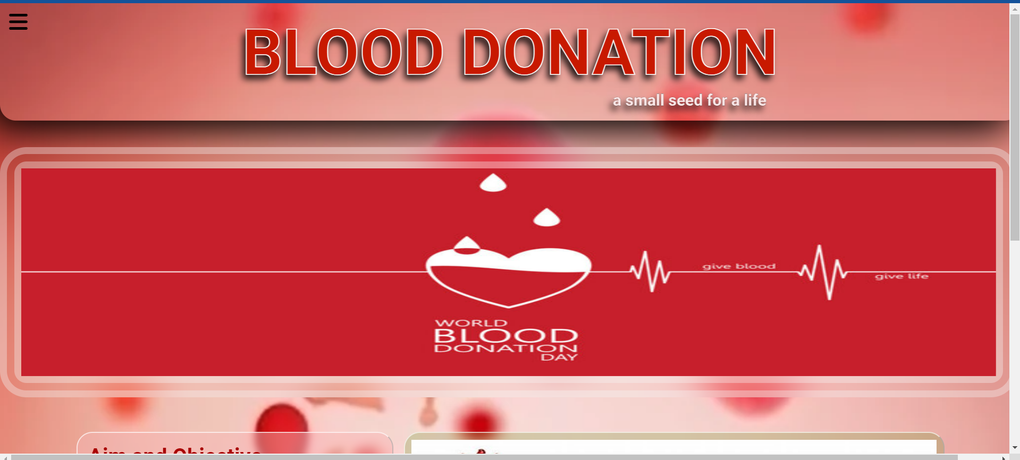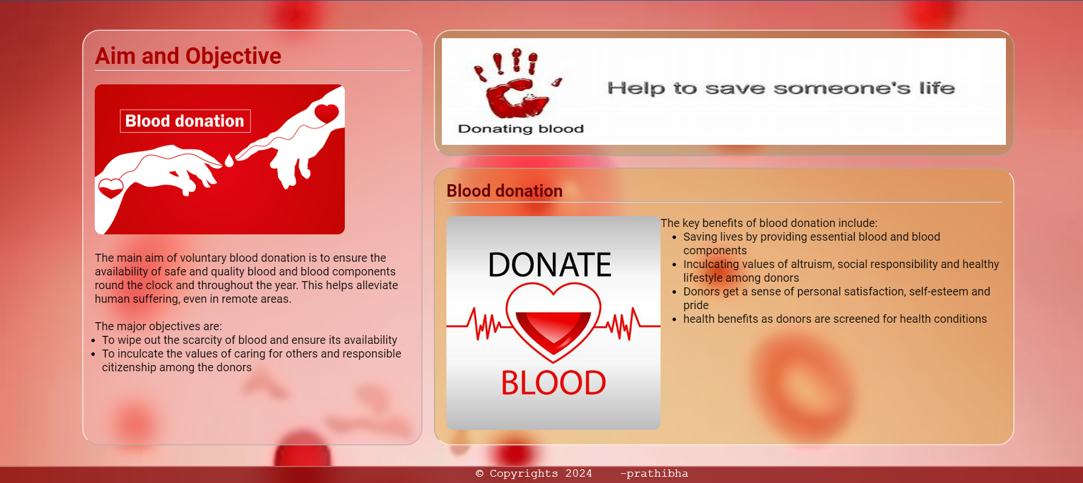

DONATION :

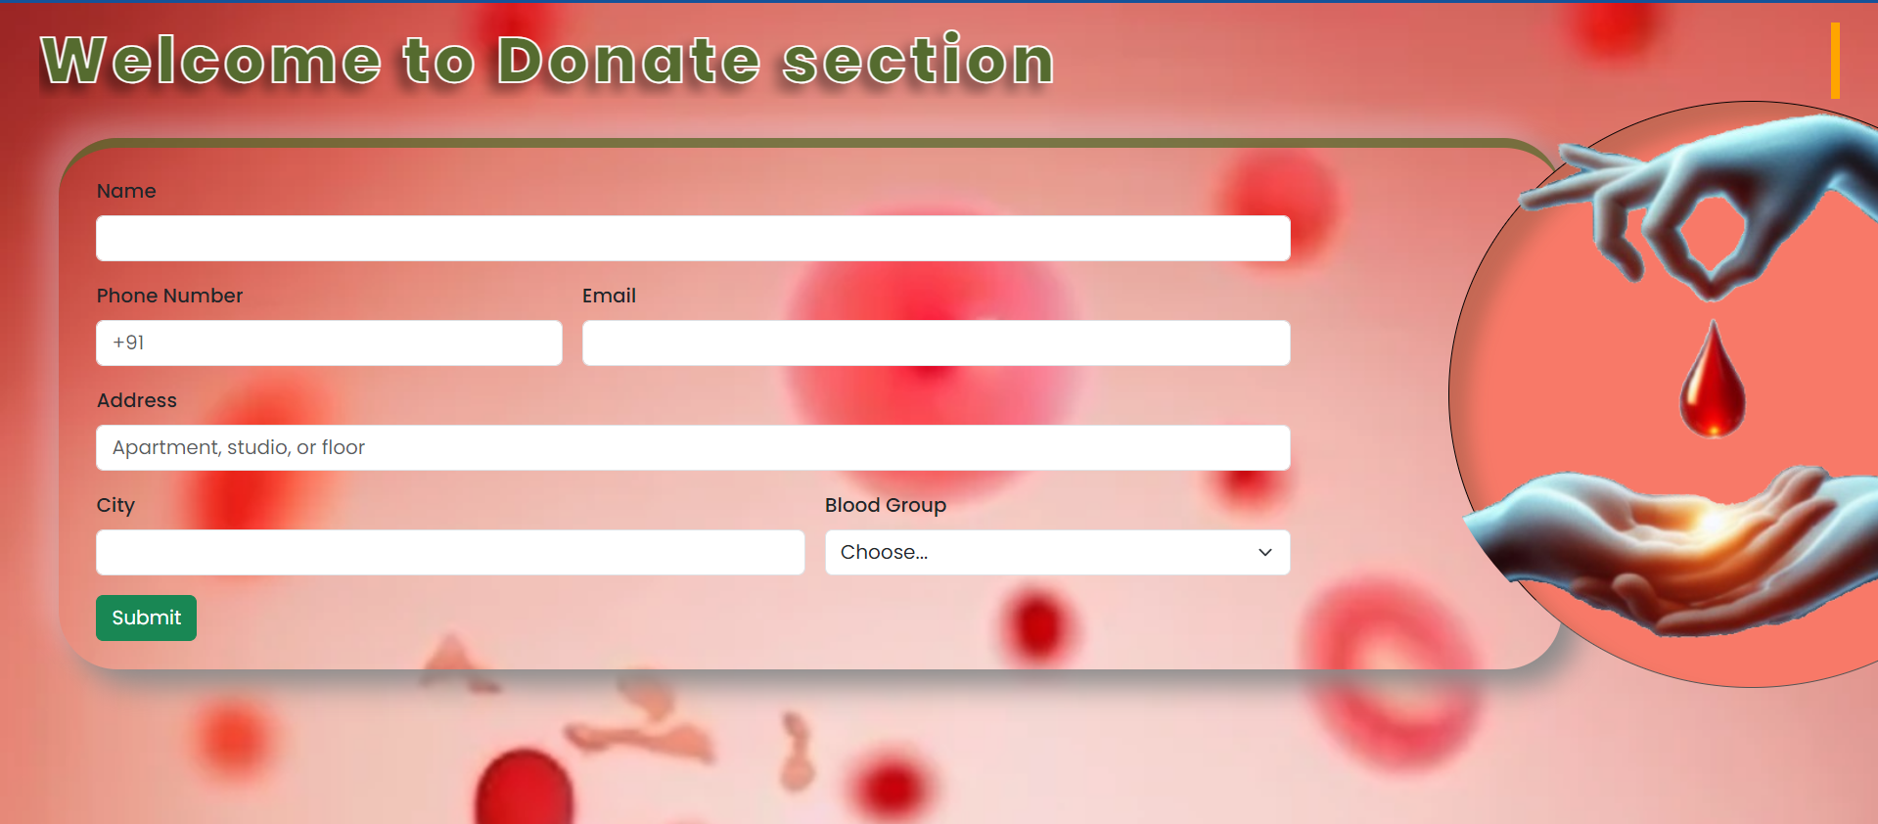

REQUEST:

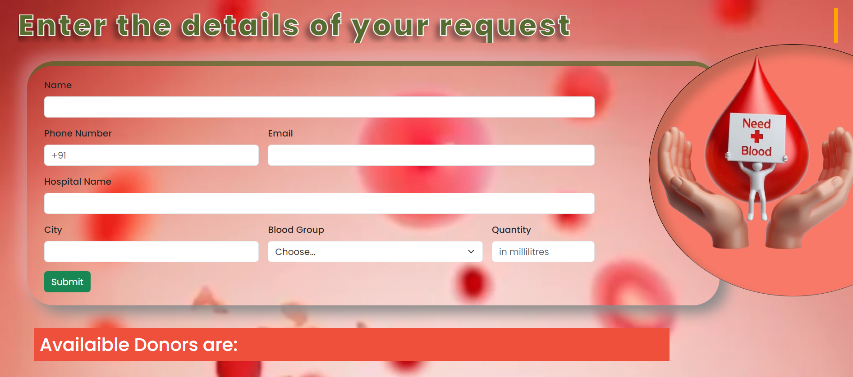

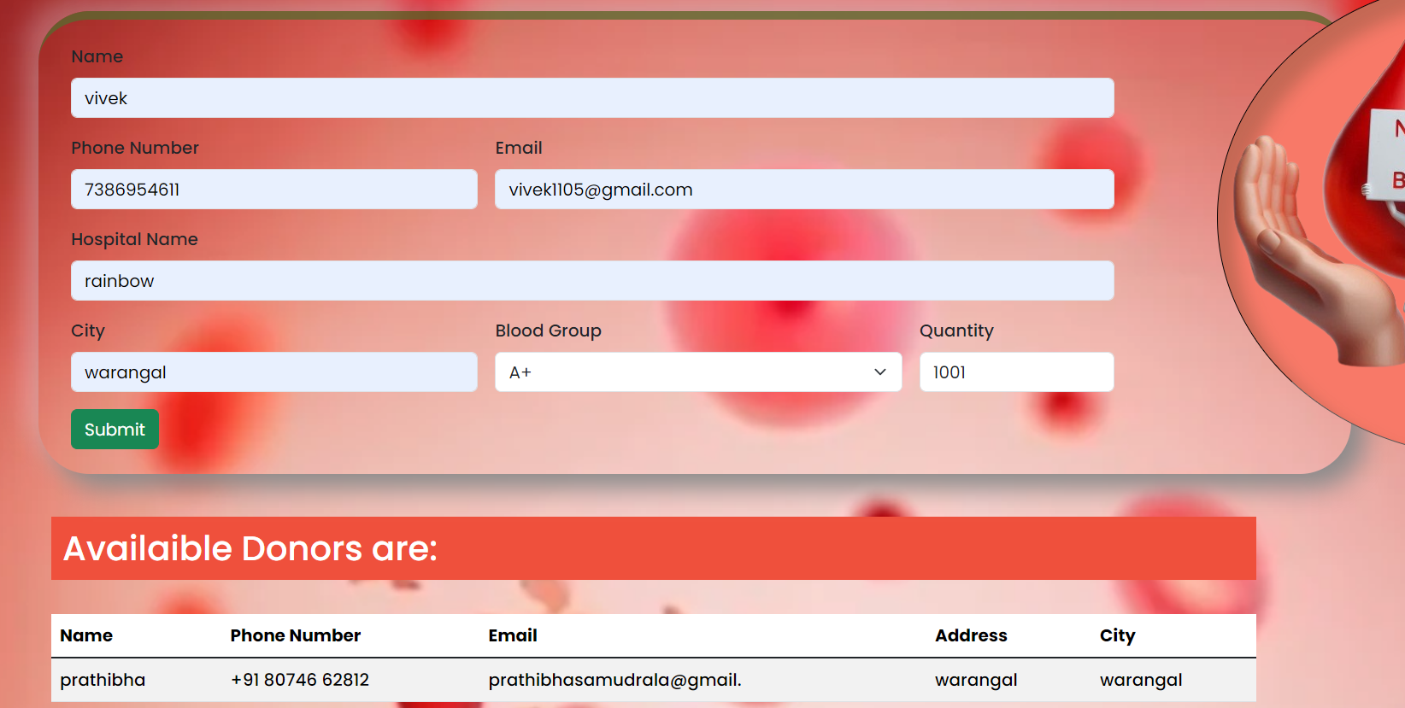

CONTACT US:

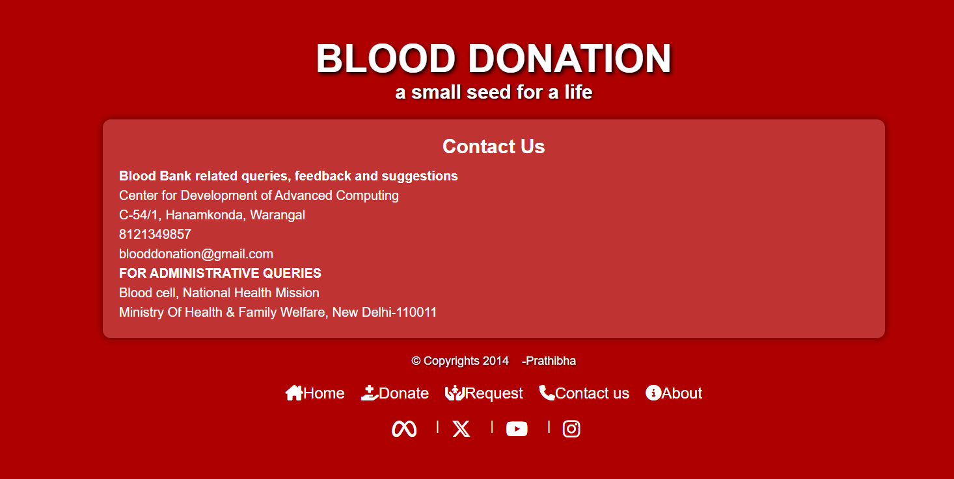

ABOUT US:

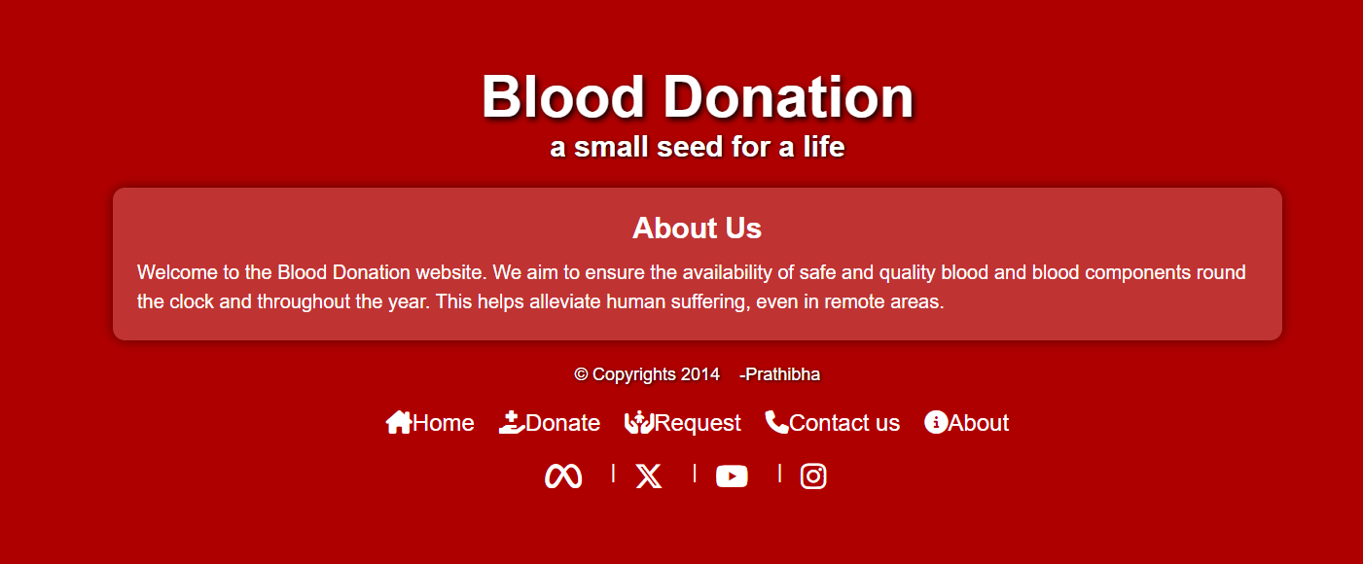

DONOR DATABASE:

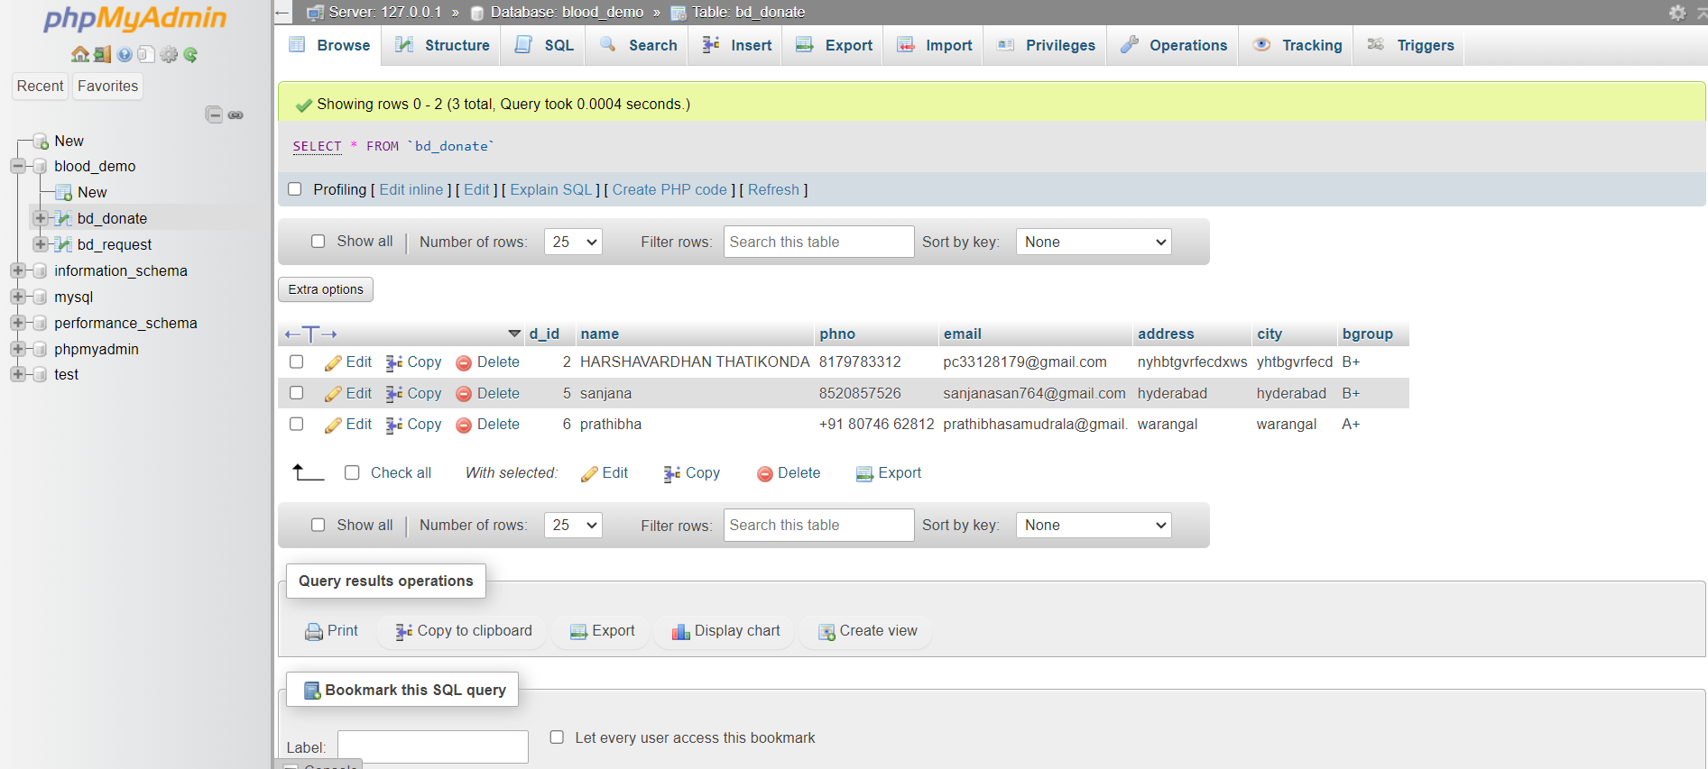

RECEIVER DATABASE:

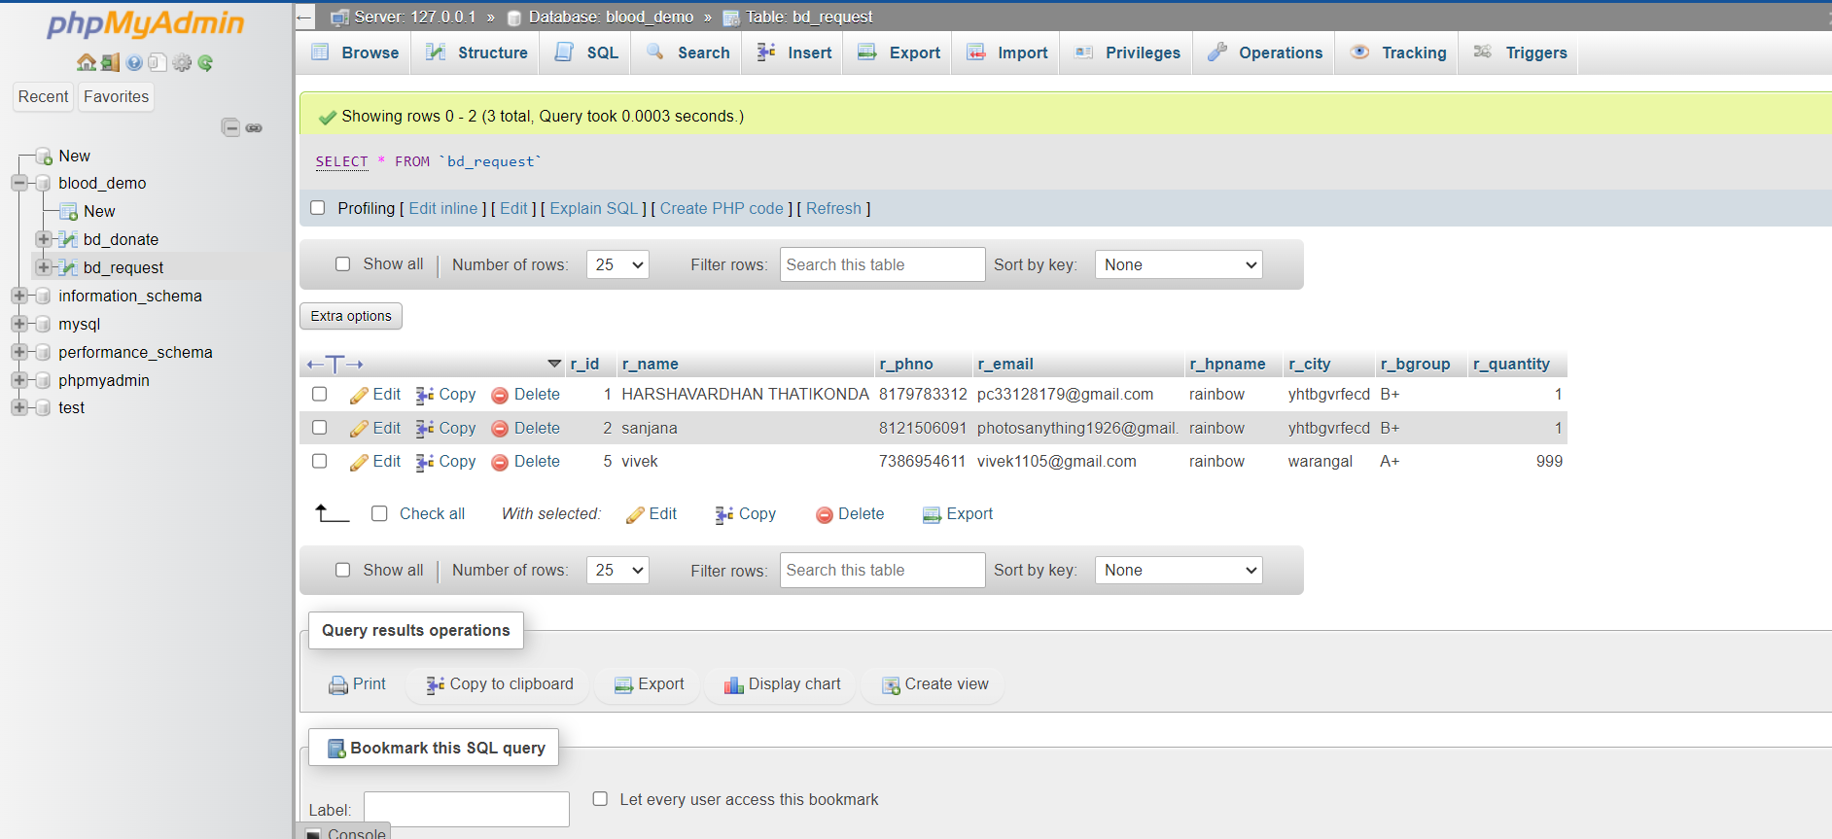

# CONCLUSION:

Our Blood Bank Website aims to revolutionize the way blood donations are managed and matched with patient needs. By providing an integrated, user-friendly platform, we address the inefficiencies and delays that often plague traditional blood bank systems. Through secure and efficient database management, powered by robust backend technology, we ensure that both donors and recipients experience a seamless and supportive process. By joining our platform, you contribute to a vital public health initiative, helping to ensure that life-saving blood is always available for those in need. Together, we can make a significant impact and save lives through the simple yet powerful act of blood donation.